WEEK 6 - ReactJS
Name: Suraj Singh
Superset ID: 7808362

Cricket App
Steps:
1. Create a new React app using the command:
npx create-react-app cricketapp
2. Navigate to the app folder:
cd cricketapp
3. Modify App.js with the following content:

Objective:
To display cricket player details using React components and props.

Steps:

1.Initialize App:
npx create-react-app cricketapp
cd cricketapp

2.Create Player Details Components File:
import React from 'react';

function PlayerDetails(props) {
return (
<div>
<h2>{props.name}</h2>
<p>Runs: {props.runs}</p>
<p>Country: {props.country}</p>
</div>
);
}

export default PlayerDetails;
- Modify App.js
import React from 'react';
import PlayerDetails from './PlayerDetails';

function App() {
return (
<div>
<PlayerDetails name="Virat Kohli" runs={12000} country="India" />
</div>
);
}
export default App;
- Run App:
npm start
- Output : Flag= True
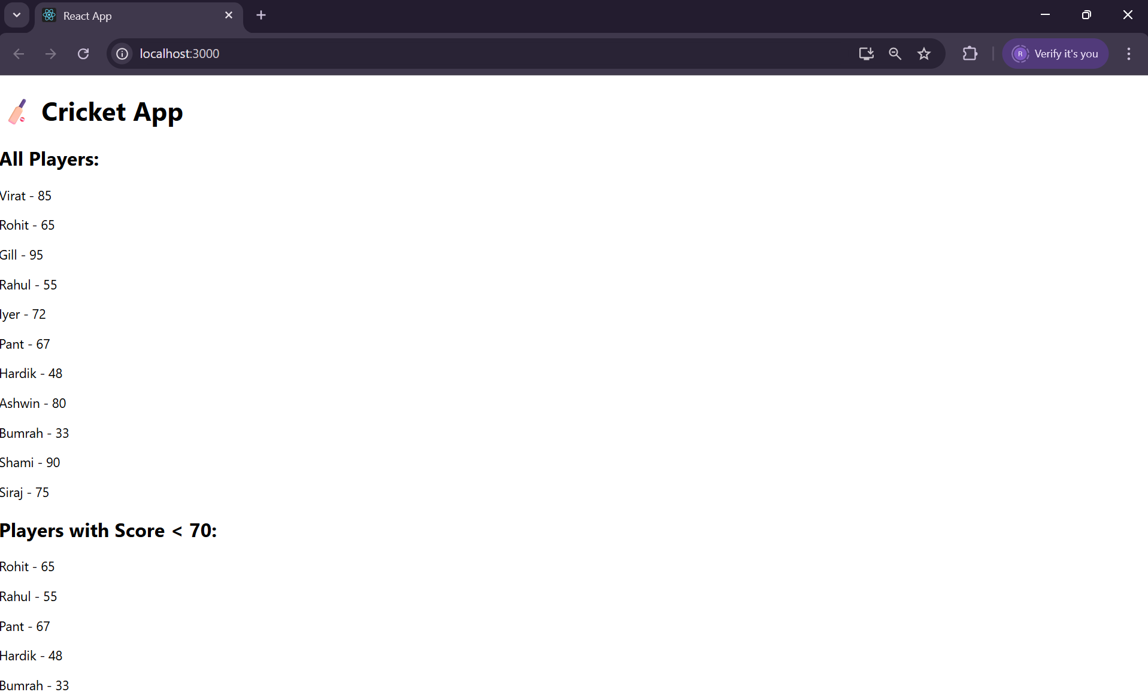
Flag = False
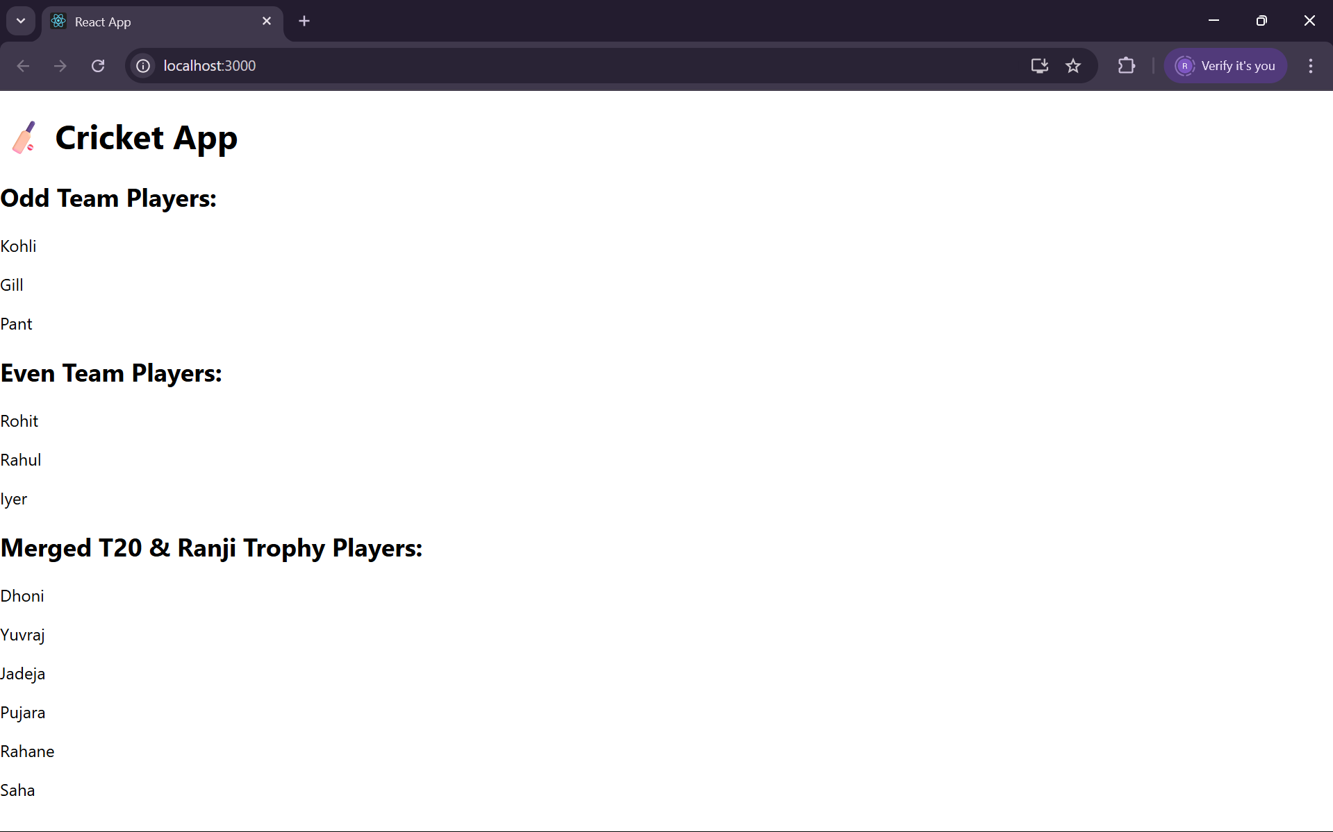

10. Office Space Rental App

Objective:
To display available office space details using a component.

Steps:
- Initialize App:
npx create-react-app officespacerentalapp
cd officespacerentalapp
- Create SpaceDetails Components File:
import React from 'react';

function SpaceDetails({ name, location, price }) {
return (
<div>
<h2>{name}</h2>
<p>Location: {location}</p>
<p>Price: ₹{price}/month</p>
</div>
);
}
export default SpaceDetails;
- Modify App.js:
import React from 'react';
import SpaceDetails from './SpaceDetails';

function App() {
return (
<div>
<SpaceDetails name="Tech Park" location="Chennai" price={50000} />
</div>
);
}

export default App;
- Run App:
npm start
- Output:
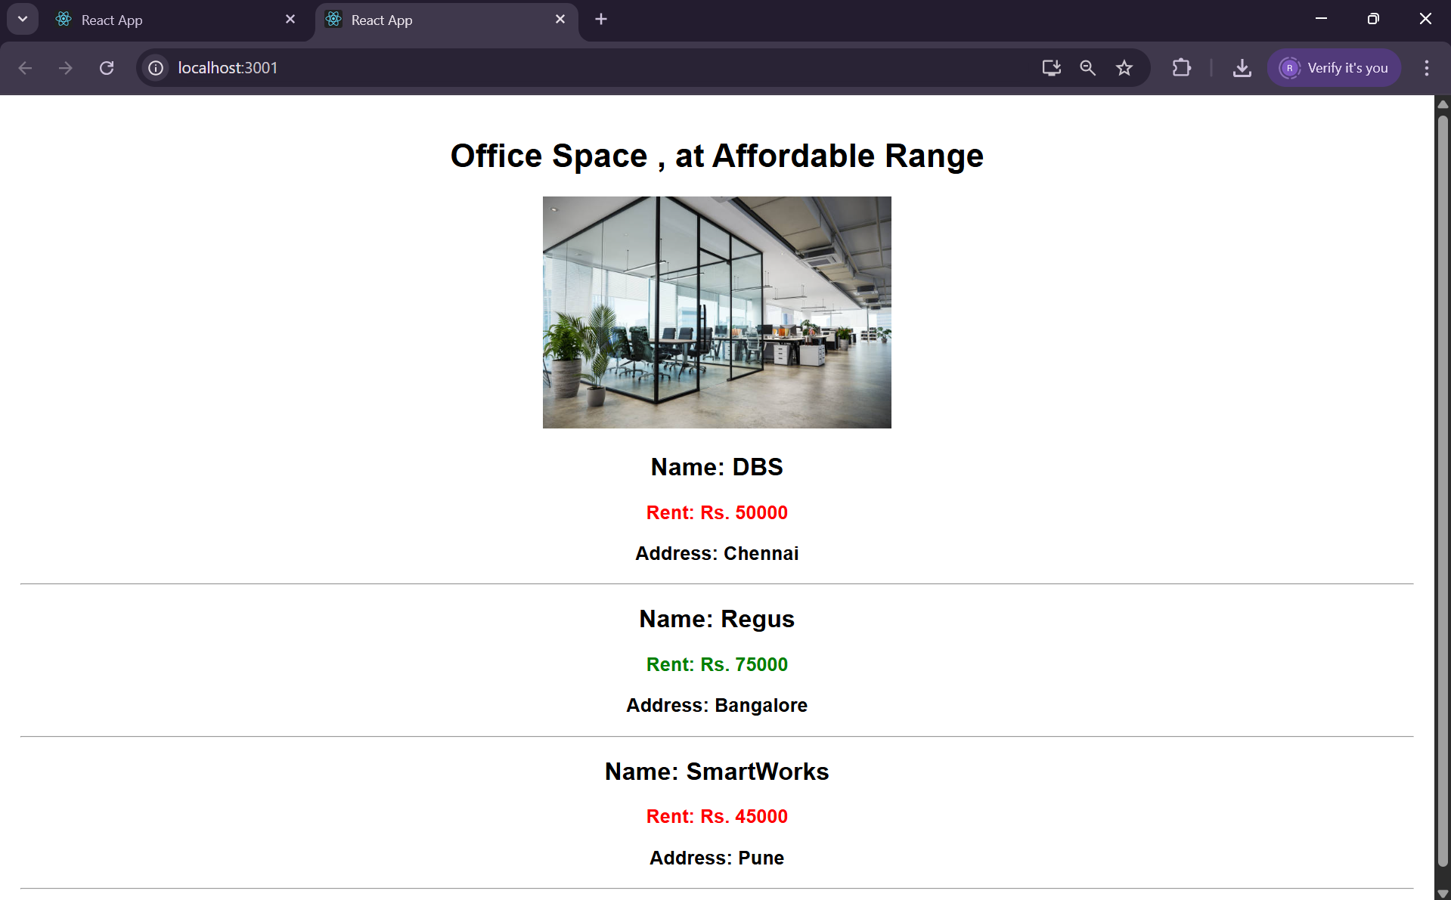

11. Event Examples App

Objective:
To demonstrate event handling in React.

Steps:
- Initialize App:
npx create-react-app eventexamplesapp
cd eventexamplesapp
- Create EventButton Component File:
import React from 'react';

function EventButton() {
const handleClick = () => {
alert('Button was clicked!');
};

return <button onClick={handleClick}>Click Me</button>;
}

export default EventButton;
- Modify App.js :
import React from 'react';
import EventButton from './EventButton';

function App() {
return (
<div>
<EventButton />
</div>
);
}

export default App;
- Run App:
npm start
- Output:
Currency Convertor:
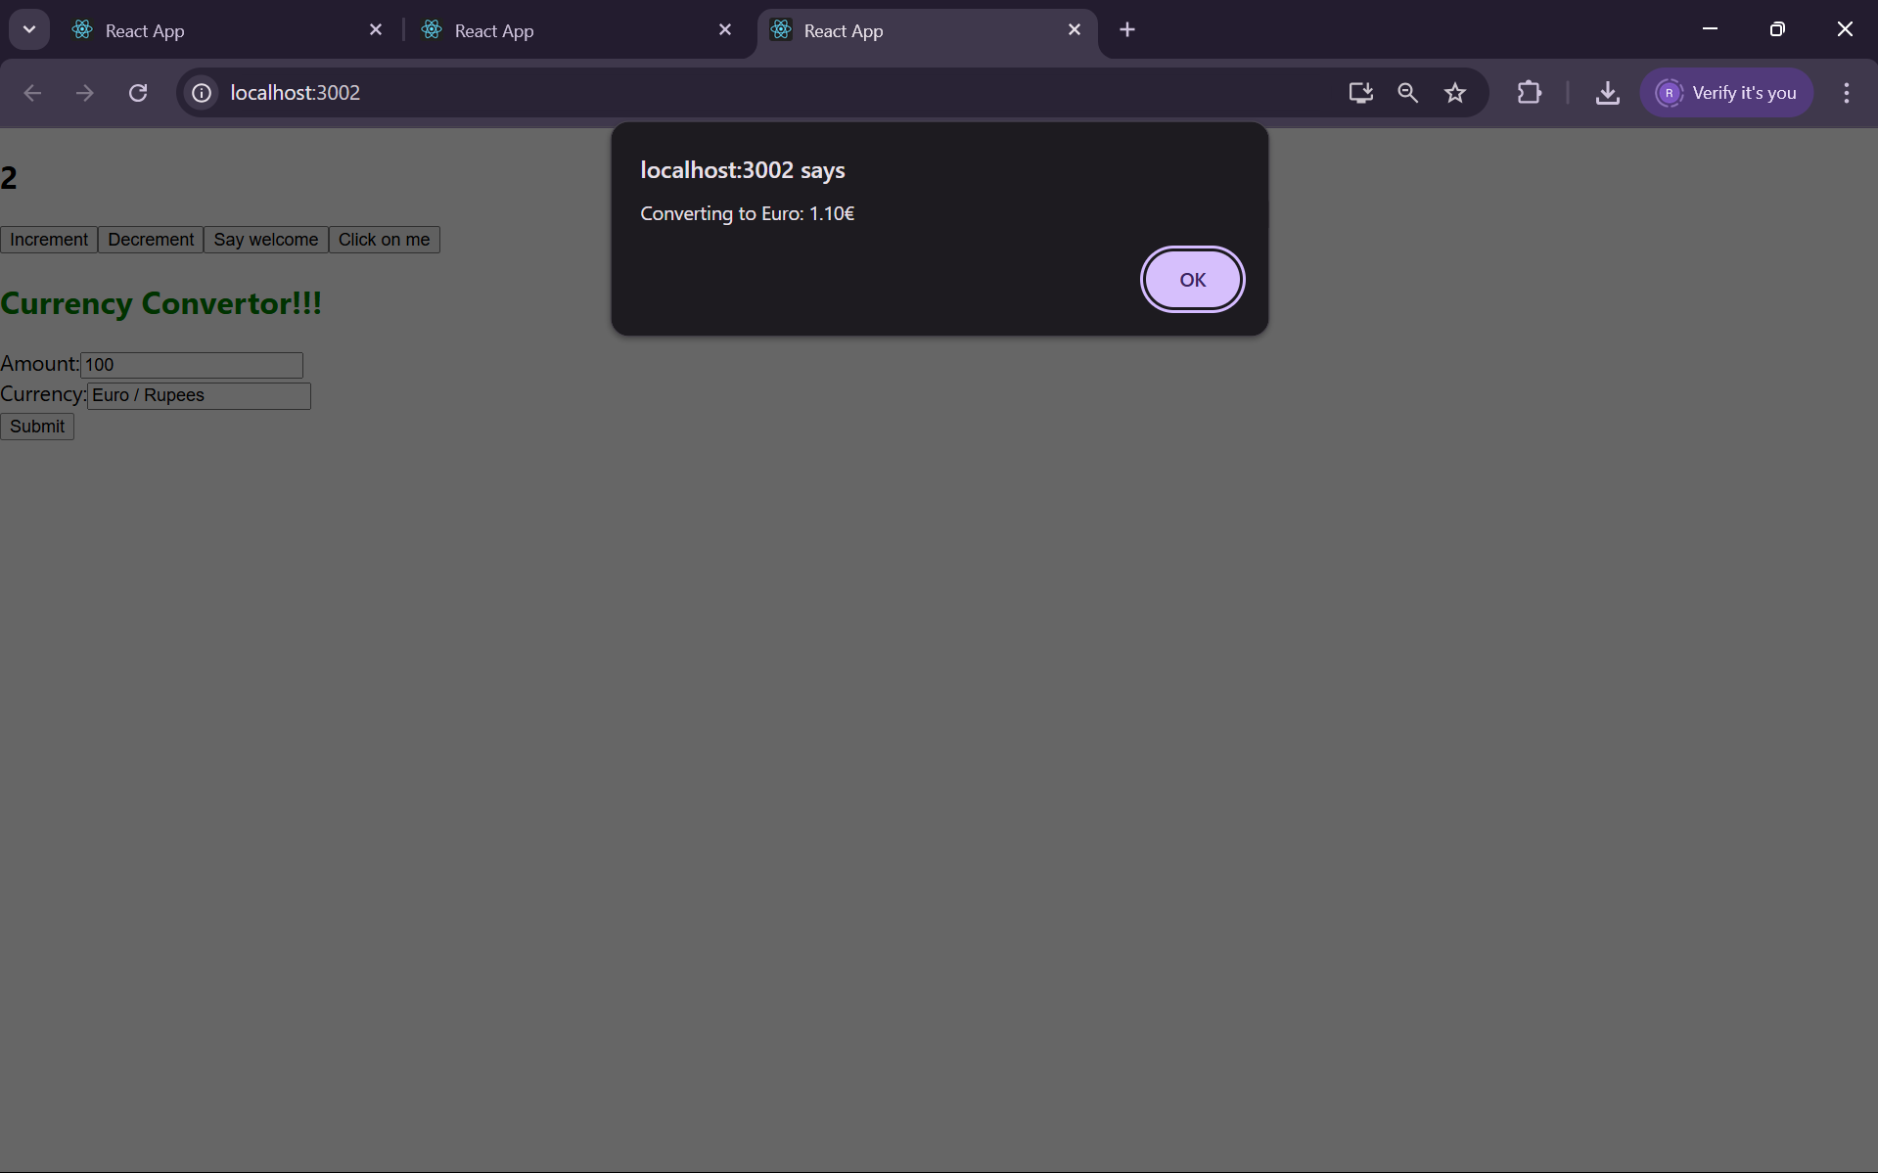
Hello Incrementer
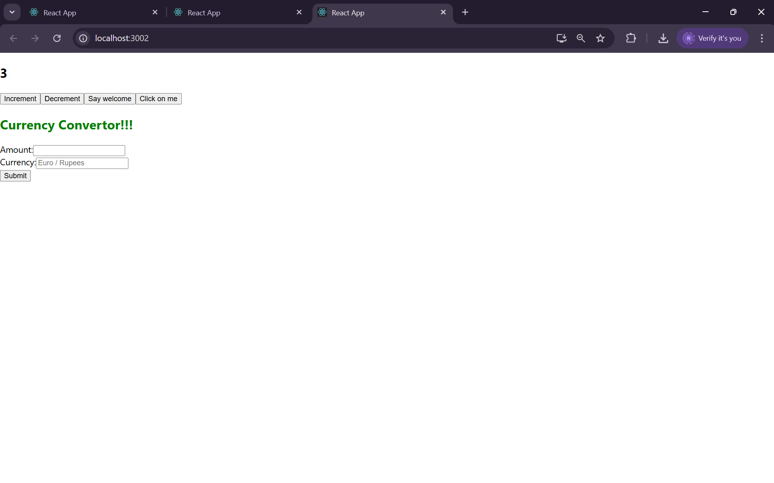
Hello Decrementer
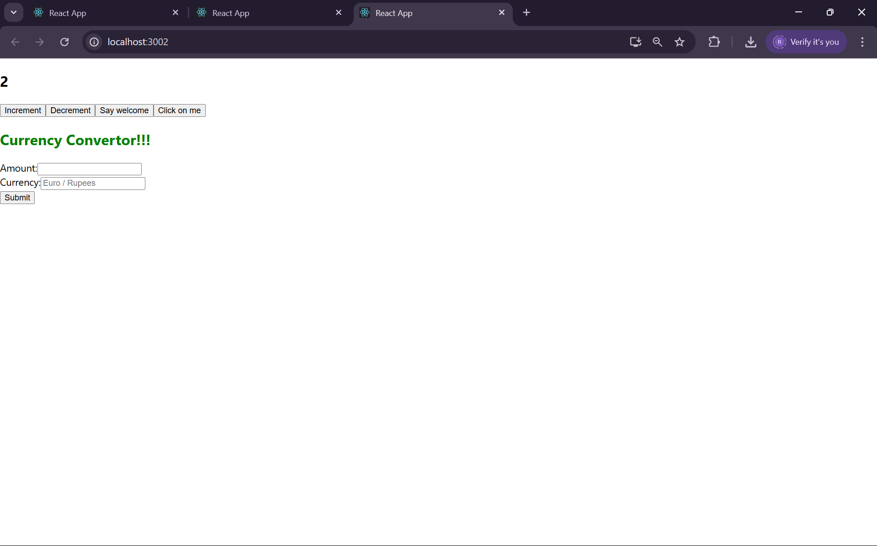

Welcome Output
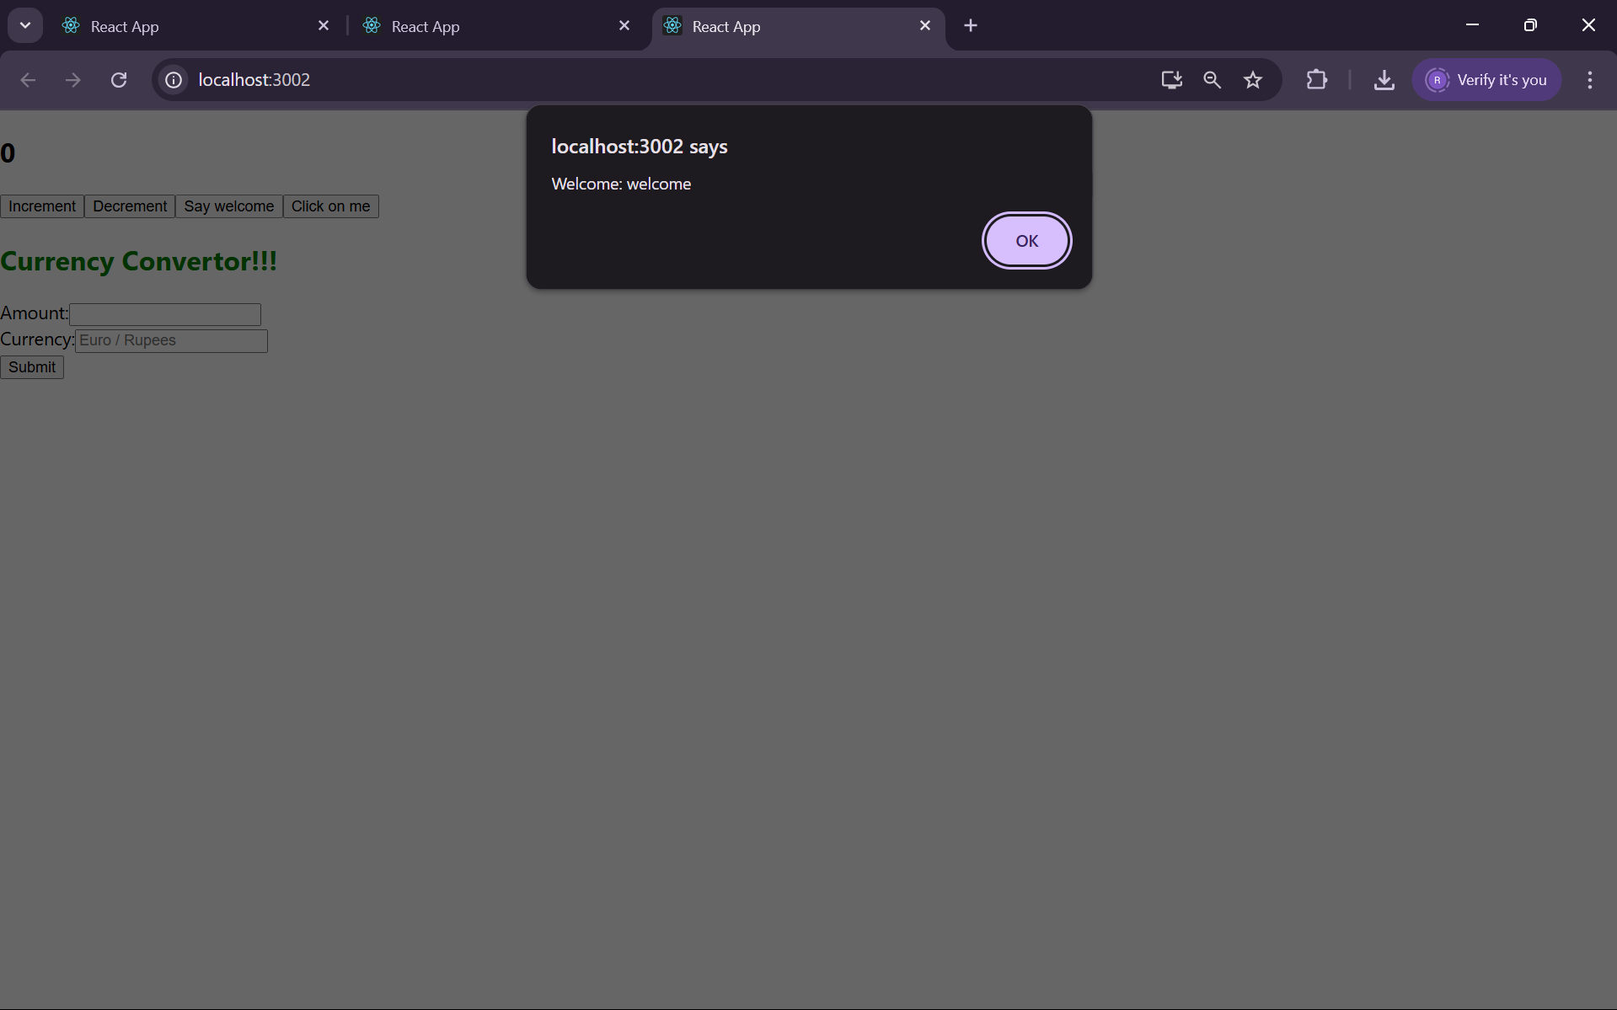
I was clicked output
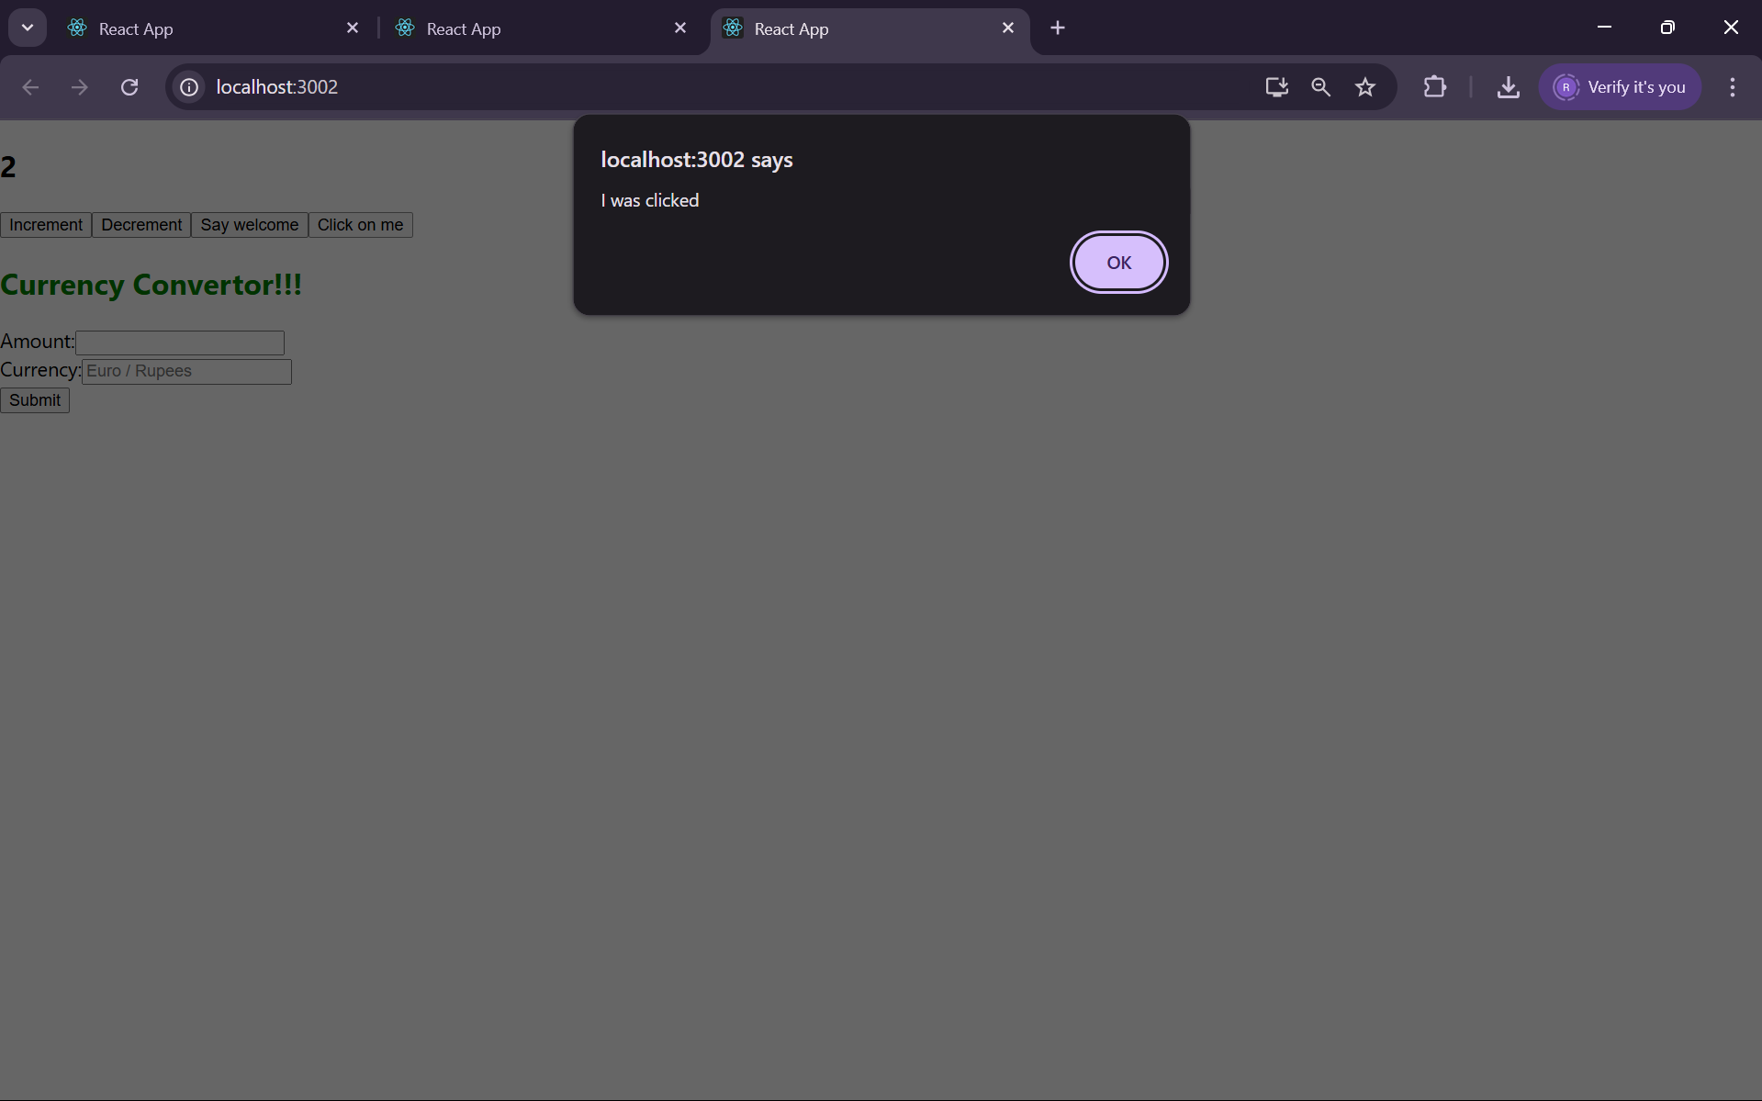

12. Ticket Booking App

Objective:
To simulate a basic login and booking interface using conditional rendering.

Steps:

Initialize App:
npx create-react-app ticketbookingapp
cd ticketbookingapp

Create Components:
Login.js
import React from 'react';

function Login({ onLogin }) {
return <button onClick={onLogin}>Login</button>;
}

export default Login;
Booking.js
import React from 'react';

function Booking() {
return <h2>Welcome to Ticket Booking</h2>;
}

export default Booking;
- Modify App.js:
import React, { useState } from 'react';
import Login from './Login';
import Booking from './Booking';

function App() {
const [loggedIn, setLoggedIn] = useState(false);

return (
<div>
{loggedIn ? <Booking /> : <Login onLogin={() => setLoggedIn(true)} />}
</div>
);
}
export default App;
- Run App:
npm start
- Output:
Booking page
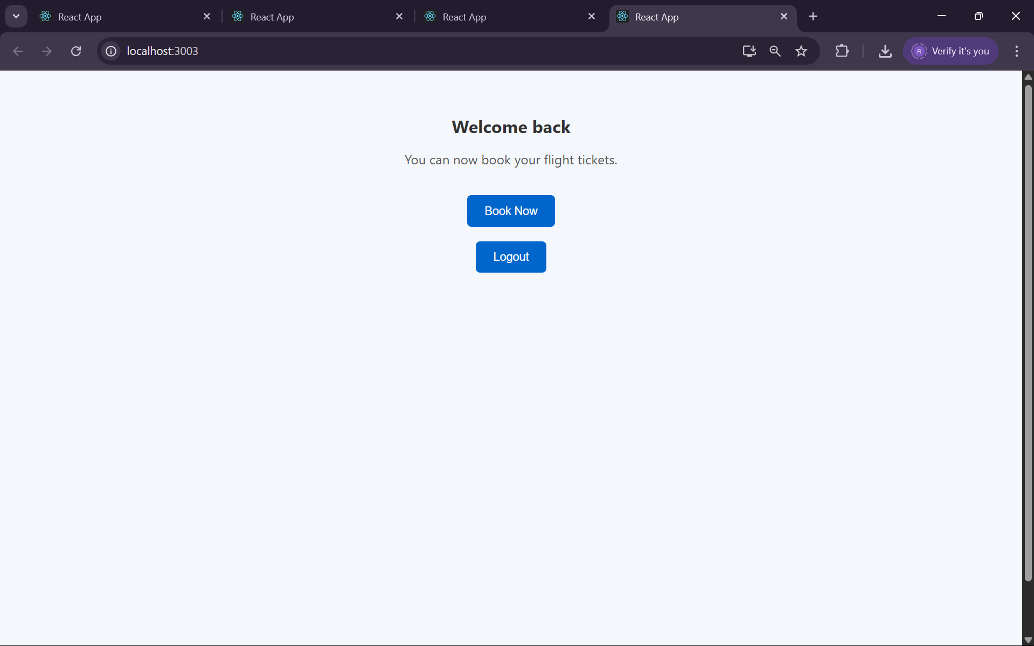
Login Page
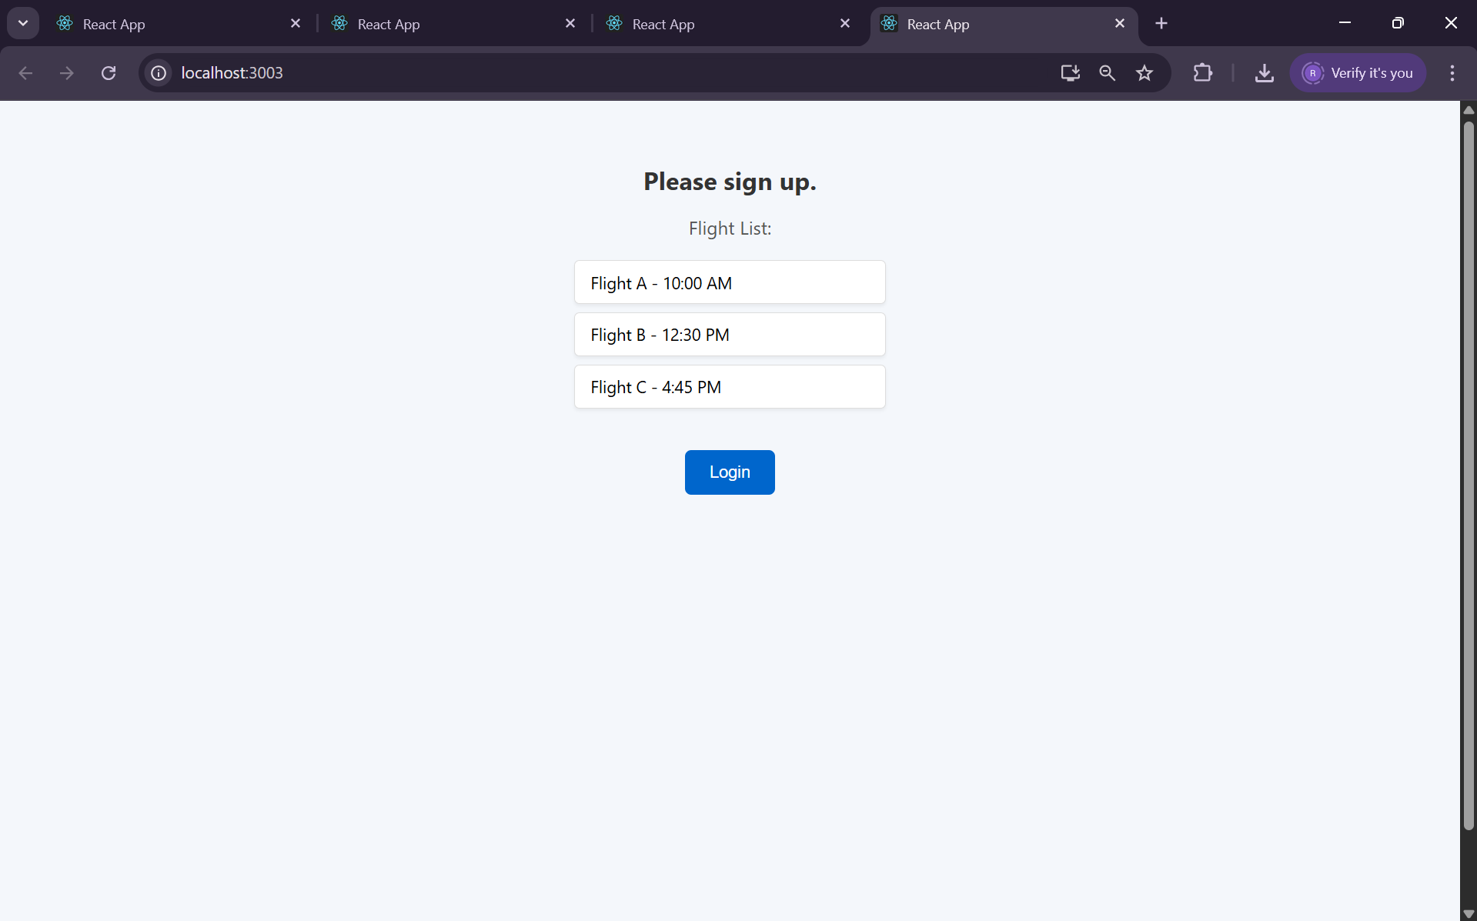

13. Blogger App

Objective:
To create a blogging page using lists and props.

Steps:

Initialize App:

npx create-react-app bloggerapp

cd bloggerapp

Create Components:
import React from 'react';
function BlogList({ blogs }) {
return (
<div>
<h2>Blogs</h2>
<ul>
{blogs.map((blog, index) => (
<li key={index}>{blog.title} by {blog.author}</li>
))}
</ul>
</div>
);
}
export default BlogList;
Modify App.js:
import React from 'react';
import BlogList from './BlogList';

function App() {
const blogs = [
{ title: "React Basics", author: "Teja" },
{ title: "Props & State", author: "Teja" }
];

return <BlogList blogs={blogs} />;
}

export default App;
Run App:
npm start
Output:
